**DAILY ONLINE ACTIVITIES SUMMARY**

|  |  |  |  |  |  |  |  |
| --- | --- | --- | --- | --- | --- | --- | --- |
| **Date:** | **20/06/2020** | | | | **Name:** | **Imran Khan** | |
| **Sem & Sec** | **8th A** | | | | **USN:** | **4AL16CS040** | |
| **Online Test Summary** | | | | | | | |
| **Subject** | | **---** | | | | | |
| **Max. Marks** | | **--** | | **Score** | | **----** | |
| **Certification Course Summary** | | | | | | | |
| **Course** | **jquery** | | | | | | |
| **Certificate Provider** | | | **udemy** | **Duration** | | | **2.5 HOURS** |
| **Coding Challenges** | | | | | | | |
| Problem Statement:   C Program. | | | | | | | |
| **Status: Solved** | | | | | | | |
| **Uploaded the report in Github** | | | | **yes** | | | |
| **If yes Repository name** | | | | **Imran040** | | | |
| **Uploaded the report in slack** | | | | **yes** | | | |

**Certification Course Details**:

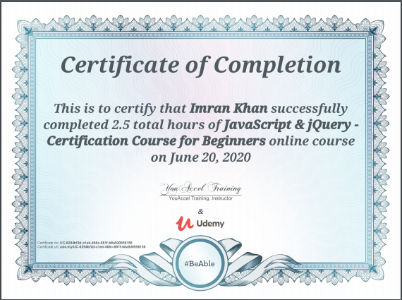

**Coding Challenges Details**:

**program1:**

|  |  |  |  |
| --- | --- | --- | --- |
|  | | | |
|  | |
| #include <stdio.h> | |
|  | |  |
|  | | void rotate(int arr[], int n) |
|  | | { |
|  | | int x = arr[n-1], i; |
|  | | for (i = n-1; i > 0; i--) |
|  | | arr[i] = arr[i-1]; |
|  | | arr[0] = x; |
|  | | } |
|  | |  |
|  | | int main() |
|  | | { |
|  | | int arr[10], n, k, i, j; |
|  | |  |
|  | | printf("Enter the no. of elements: "); |
|  | | scanf("%d", &n); |
|  | |  |
|  | | printf("Enter the elements: "); |
|  | | for (i = 0; i < n; i++) |
|  | | scanf("%d", &arr[i]); |
|  | |  |
|  | | printf("Enter the no. of times to rotate: "); |
|  | | scanf("%d", &k); |
|  | |  |
|  | | for(j = 0; j < k; j++) |
|  | | { |
|  | | rotate(arr, n); |
|  | | } |
|  | |  |
|  | | for (i = 0; i < n; i++) |
|  | | printf("Element at index %d: %d\n", i+1, arr[i]); |
|  | | return 0; |
|  | | } |